**St. Francis Institute of Technology**

**Class: SE-ITA/ITB Semester: IV; A.Y. 2023-2024**

**Subject: Microprocessor Lab**

**Experiment – 6:** Linear search for a given element in an array

**1. Aim**:

Write an ALP to search for a given element in an array.

**2. Requirements**

DOSBox (an x86 emulator with DOS), Turbo Assembler, Turbo Debugger

**3. Pre-Experiment Exercise**

**Algorithm:**

a. Initialize an array of 8 bit numbers and the number that is to be searched.

b. Use a MACRO to display messages on the output screen.

c. Define a procedure to compare the number with all elements in the array. d. If the number equals any of the elements of the array, then print “Number found” else print “Number not found”

**4. Laboratory Exercise:**

**Procedure:**

a. Open DOSbox and go to TASM.

b. Open a new document using the command - edit <filename>.asm

c. Write the Program and save the changes to the same file.

d. Assemble the program using the command - tasm <filename.asm>

e. If any errors are displayed, then change the code in <filename>

f. If no errors are displayed, execute the command - tlink <filename>.obj to create the executable file.

g. Next execute the command - <filename>

h. Check the result displayed.

**5. Post Experiment Exercise:**

**a. Results/Calculations/Observations:**

Attach screenshots, one of number found in the array and another of number not found in the array along with the ALP.

**b. Questions:**

i. Write an ALP in TASM to find the largest number in an array. Attach appropriate screenshots.

ii. Explain different types of loop instructions used in 8086.

iii. Explain ALP commands to generate interrupt.

**c. Conclusion:**

Write the conclusion/comments based on the experiment performed and the output obtained. **d. References:**

Mention two book references and two web references.

Code: ***RIYA INDAP,44***

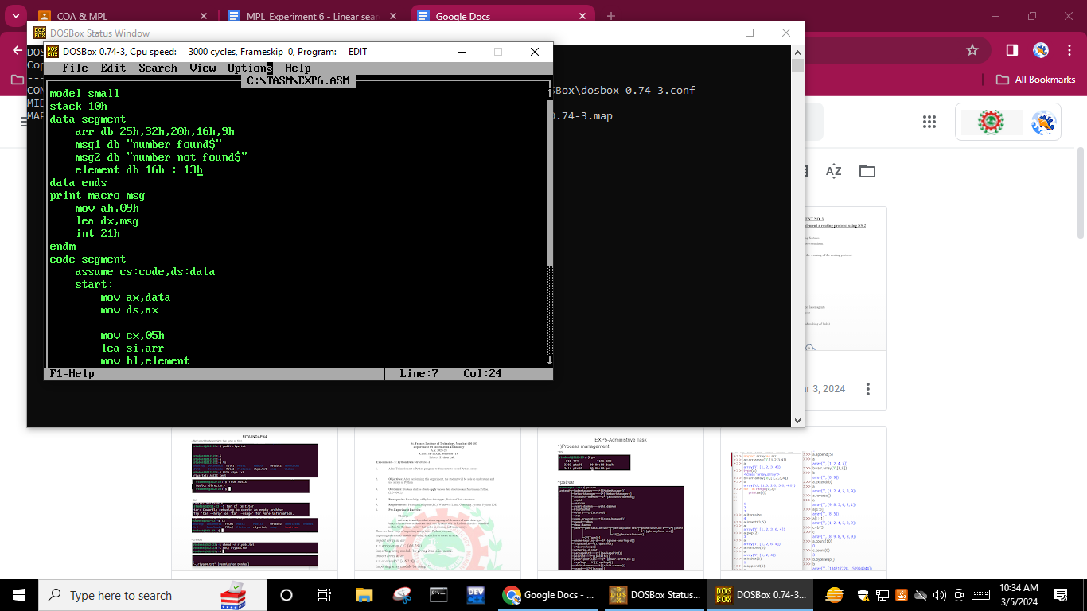

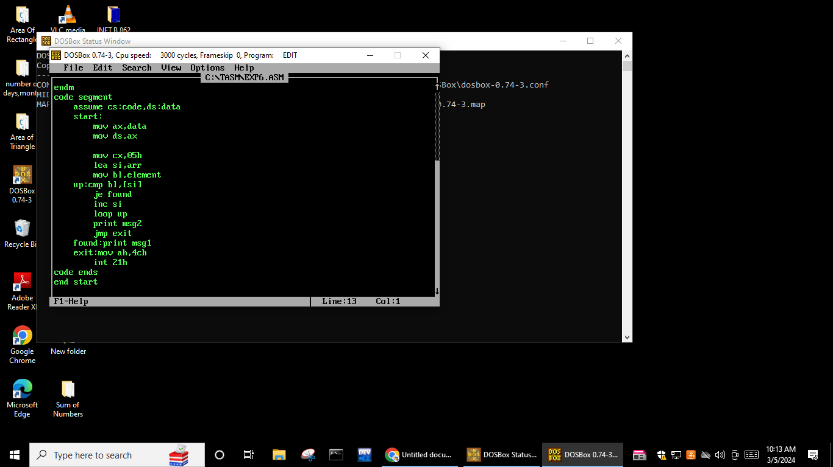

Output:

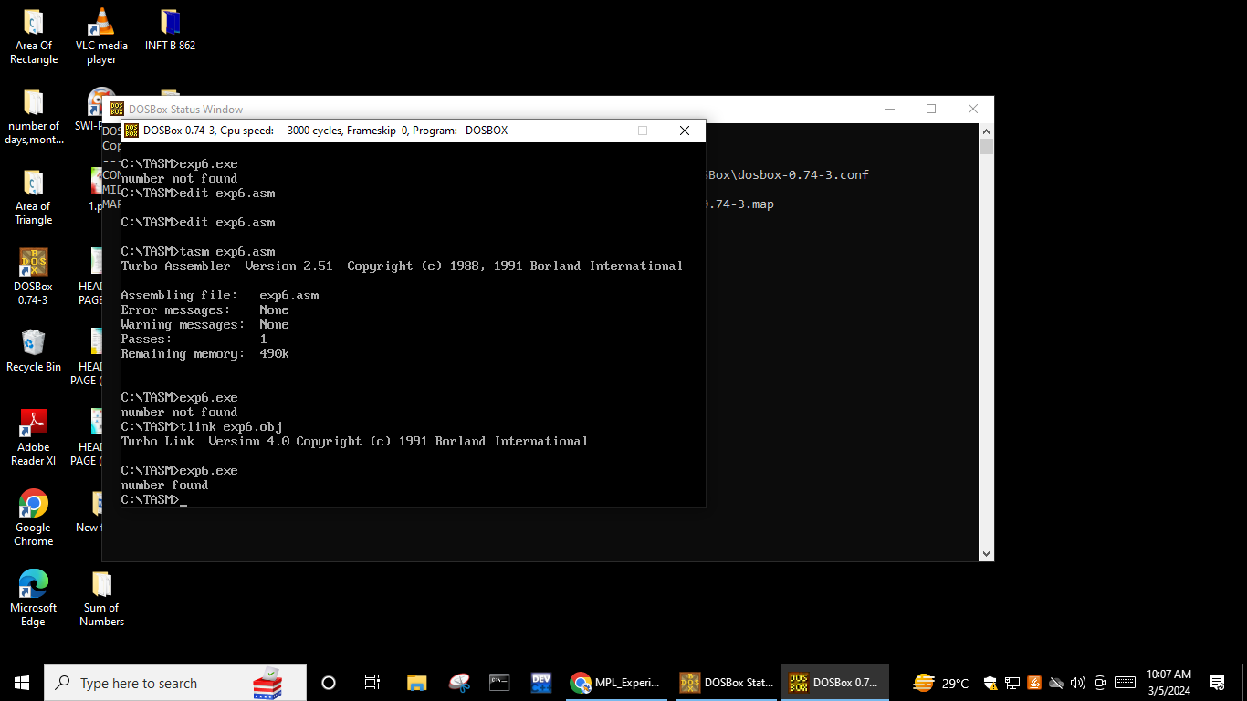



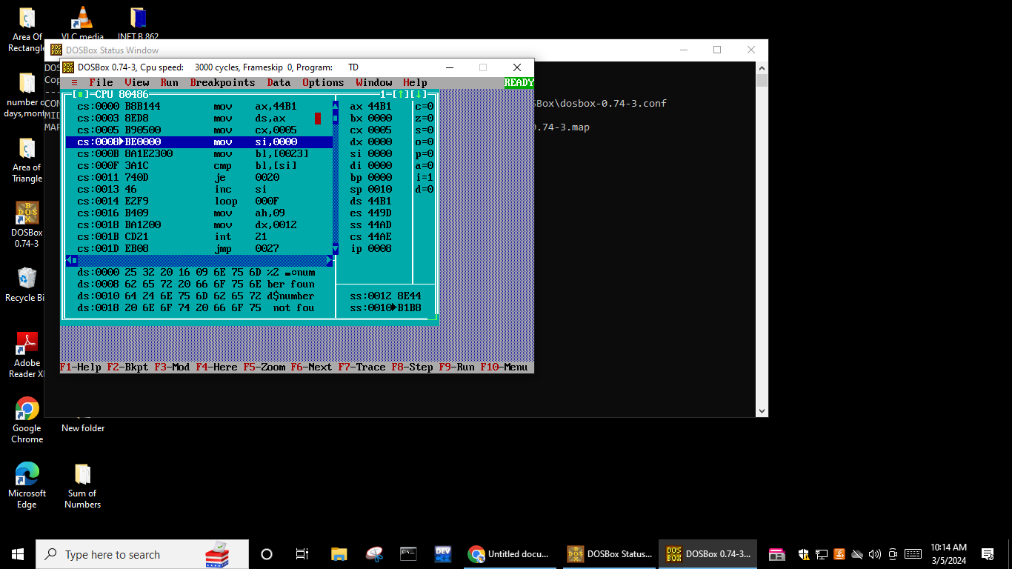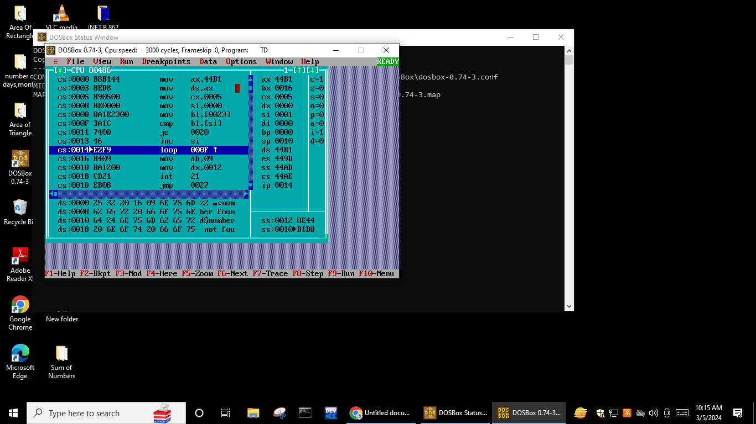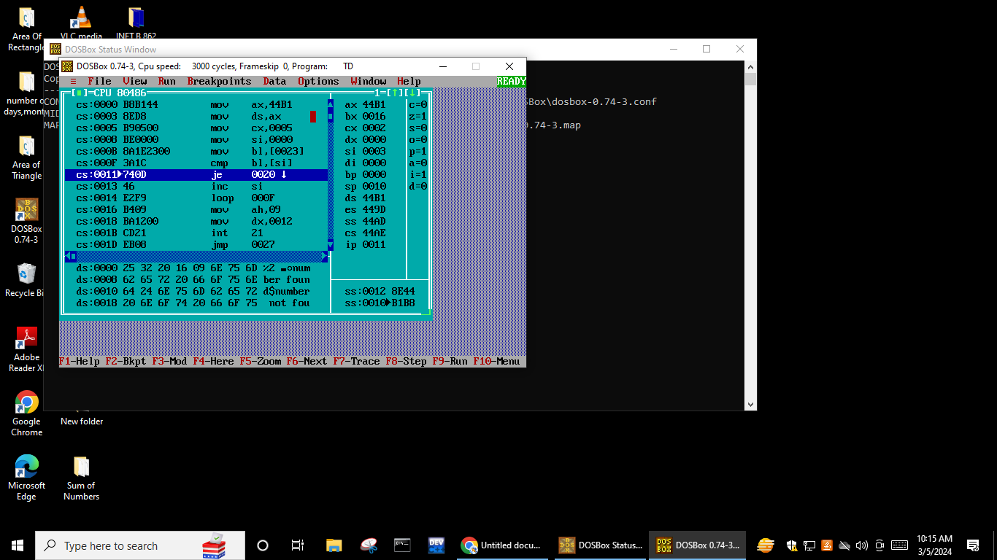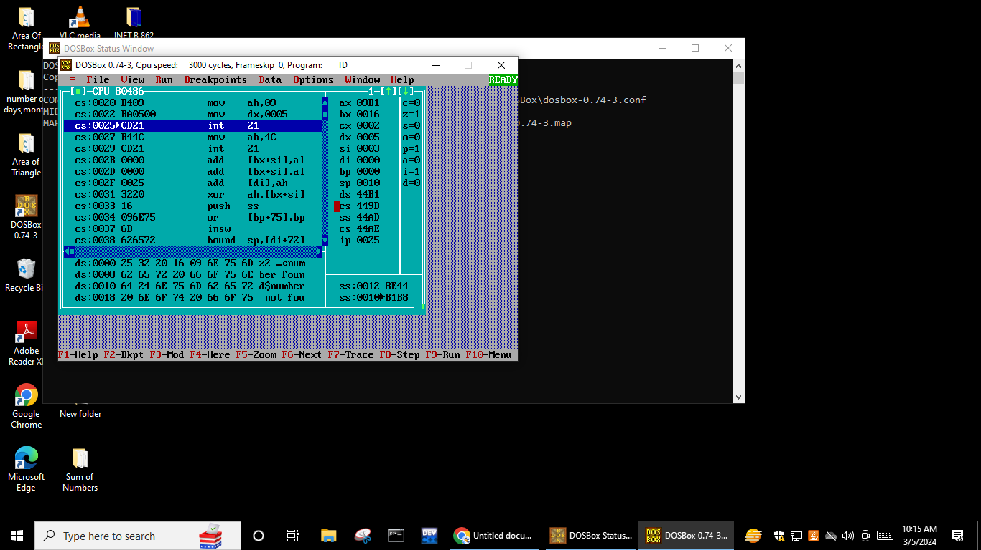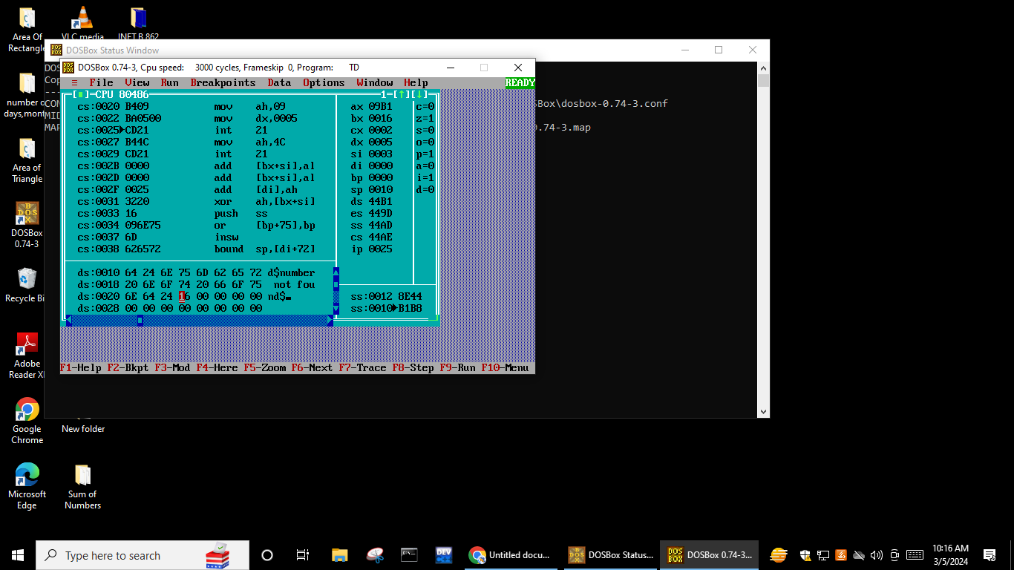

Q.Write an ALP in TASM to find the largest number in an array. Attach appropriate screenshots.

